Supplemental Material

Data Processing
Variables‘processing: For the ideological classification of each population, five categories were generated according to who they voted for in the PASO elections. Given that the final result of the electoral process is not at stake in these elections, we can infer that participants voted for those candidates with whom they most closely identified ideologically. Although participants may have changed their vote in the general election and in the second round (left-wing voters voting for progressivism, or moderate right-wing voters voting for the libertarian right), it is assumed that their ideological identification remains the same and what changes is who they support in the electoral battle. It should be noted that the moderate right-wing population was evaluated separately according to who they voted for in the PASO, as subsequent analyses showed differences between groups.
Thus, from the PASO_vote variable, the levels referring to equivalent political forces/candidates were collapsed to create the PASO_vote_category variable, with the following levels: 1. Left-wing; 2. Progressivism; 3. Centre; 4. Moderate right-wing; and 5. Libertarian right-wing. Only in the case of Moderate Right-wing, the voter populations for each candidate competing in the PASO within the same political force were analysed separately; thus, Moderate Right-wing (a) corresponds to voters for candidate Larreta and Moderate Right-wing (b) to Bullrich. The reason for this segregation is that both populations, in a preliminary exploratory analysis, showed differences in the indicators assessed. All the full information is detailed in Supplementary Table 3.
For model generation, several variables were also collapsed. The variable Residence, which had all provinces of Argentina as levels, was grouped by region: North, Patagonia, Central, etc. Age was grouped according to these age ranges: 0-18, 19-35, 35-50, 50-70, 70-100 years. In the case of Peronist&anti-Peronist self-perception, they were grouped into three groups: A, B and C, the first being the group that perceives itself as Peronist, and the last as anti-Peronist.

Indices´ creation: From the robust data, several indices were calculated to perform the analysis of results:

Positivity index: to assess whether emotionality during elections could be an impact variable in our study, the positivity index was calculated using an adapted and shortened version of the Paez test (36). It consisted of 7 items for which subjects were asked to rank on a 5-point Likert scale. Items 3 and 7 had an inverted scale with respect to the others. The positivity index was calculated as the sum of the values (with items 3 and 7 inverted). Values higher than 17.5 correspond to higher positivity; lower values correspond to higher negativity.

Progressivism and Conservatism Indexes: They were obtained using a shortened version of the previously published scales (37). For both scales, 10 different items were presented, with either progressive or conservative content, and subjects were asked to rank their agreement or disagreement on a 5-point Likert scale. The items are described in the Supplementary Table 2. The index was calculated as the average of the responses. To aid in the visualisation of the results, the values of each item were inverted, so that a higher index value corresponds to a higher level of conservatism or progressivism.
In addition to the responses for each item, response time was measured to calculate the mean and median response time associated with progressive or conservative indices.

Opinion Change Indexes (OCI): to assess whether association with a candidate changes the degree of agreement or disagreement that subjects have regarding progressive or conservative items, the Opinion Change Index was calculated by each item as:

OCI_{item(i;c)} = $Item\left(i\right)-Item(i;c)$
“i” refers to the item i within the conservative or progressive scale.
“c” refers to the ideological condition of the candidate associated with the item, whether right-wing or left-wing. Therefore, “c” can be “r” if it is associated with the right-wing candidate, or “l” if it is associated with the left-wing candidate.

In order to explore the general conditions for opinion change, 8 new variables were generated:

OCI _{con} = $\frac{\sum{}[Icon\left(i\right)-Icon(i;c)]}{n}$  OCI _{con;r} = $\frac{\sum{}[Icon\left(i\right)-Icon(i;r)]}{n}$  OCI _{con;l} = $\frac{\sum{}[Icon\left(i\right)-Icon(i;l)]}{n}$ | OCI _{pro} = $\frac{\sum{}[Ipro\left(i\right)-Ipro(i;c)]}{n}$  OCI _{pro;r} = $\frac{\sum{}[Ipro\left(i\right)-Ipro(i;r)]}{n}$  OCI _{pro;l} = $\frac{\sum{}[Ipro\left(i\right)-Ipro(i;l)]}{n}$
OCI _{CON} = $\frac{\sum{}[Icon\left(i\right)-Icon(i;r)]+\sum{}[Ipro\left(i\right)-Ipro(i;l)]}{n}$

OCI _{INC} = $\frac{\sum{}[Icon\left(i\right)-Icon(i;l)]+\sum{}[Ipro\left(i\right)-Ipro(i;r)]}{n}$

Where:
“Icon(i)” corresponds to item i within the conservative scale; as likewise “Ipro(i)” to the progressive scale.
“c” refers to the condition of the item associated with a candidate, whether right-wing or left-wing; while when analysing the change of opinion separately according to the ideology of the candidate, “r” refers to the right-wing candidate, while “l” refers to the left-wing candidate.
“n” refers to all items(i) that correspond to the condition analysed and are summed.
“OCI_{CON}” refers to the congruent condition: progressive items associated to left-wing candidates and conservative items associated to right-wing candidates.
“OCI_{INC}” refers to the incongruent condition: progressive items associated to right-wing candidates and conservative items associated to left-wing candidates.

The exploratory analysis showed that there were no significant differences in the ratings of OCI_{con;r}, OCI_{con;r}, OCI_{con;l}, OCI_{pro;r}, and OCI_{pro;l}. For this reason, the central analysis of this article focuses on the change of opinion for each item. A relevant consideration is that our experimental design allows us to discriminate between congruent associations (OCI_{CON}: OCI_{con;r} and OCI_{pro;l}) and incongruent associations (OCI_{INC}: OCI_{con;l} and OCI_{pro;r}). Such conditions were specifically analysed.
Besides, the difference in response time was calculated when items were associated with a candidate.

Statistical Analysis
All statistical analyses were performed with RStudio (R language) and VisualStudio (Python language).
Statistical models. To assess which independent variables are significant (and with what impact) in explaining Left-Right, Conservative-Progressive and Peronist-anti-Peronist self-perceptions, as well as the Indices of Progressivism and Conservatism, Generalised Linear Models (GLM) were run with a Gaussian distribution. Each model was first explored with all the variables of interest, and finally we were left with only the significant variables to build the final models. There was no evidence that the assumptions were not met in each case.
For Closeness to candidates, the data were processed to generate a binary dependent variable, created from the original ordinal variable by grouping its values into two categories: low (1-3) and high (4-5). This was done because the unbalanced data did not allow for fitting an Ordinal Model; therefore, Binary Models (BM) were used. Again, the final models were constructed by keeping only the significant variables. No evidence of non-compliance with the assumptions was observed in each case; except for the Milei Closeness (for General Elections data), for which the Progressivism Index variable does not meet the logit linearity assumption.
Finally, Robust Regression Models (RRM) were used to assess changes in opinion. The final models were constructed by retaining only the significant variables. No evidence was observed that the assumptions are not met in each case, except for OCI_{pro;r} which does not meet the homoscedasticity assumption. However, it is not an essential assumption in the robust model.
Statistical analysis: To evaluate the significant differences in the variables of interest between the different populations, segregated by the variable PASO_vote_category, a Kruskal-Wallis and post-hoc Dunn Test was performed.

Clustering Analysis
To identify distinct patterns of political attitudes among participants, we performed a cluster analysis based on the subjects' responses to the conservative and progressive items. This analysis was conducted separately for each group of items to explore how individuals aggregated according to their ideological leanings in both the General and Ballotage elections.
Data Preparation and Distance Metric. The raw data consisted of Likert-scale responses to 10 conservative items and 10 progressive items. To quantify the divergence between participants' ideological profiles, we calculated a dissimilarity matrix using the ratio of mismatches (Han et al., 2023, p. 45). This measure defines dissimilarity as the proportion of elements (items) for which two subjects provided different responses. The choice of this metric is justified by the categorical nature of the survey items. By treating Likert responses as nominal categories, we avoid the problematic assumption that the distance between all adjacent response levels is uniform. This approach ensures that the clustering algorithm identifies groups based on the alignment or misalignment of response patterns, providing a more conservative and robust ideological segmentation.
Clustering Algorithm. We use agglomerative hierarchical clustering, a bottom-up approach that is also deterministic, unlike other clustering algorithms such as k-means. We selected the average linkage method. This method determines the distance between two clusters as the average of the distances between all pairs of individuals in the two clusters. Average linkage was chosen for its robustness and its ability to avoid the "chaining" effect—a phenomenon where clusters are merged based on single close elements rather than overall similarity, often resulting in long, poorly separated clusters (Everitt et al., 2011, p. 79).
Determination of Optimal Clusters. The optimal number of clusters for both group of items was determined using the Elbow Method. We evaluated the total within-cluster distortion (the sum of intra-cluster distances) for a range of clusters (k=2 to 10). Following this heuristic, we identified the point where the marginal decrease in distortion begins to level off, indicating the most parsimonious cluster solution by balancing model complexity and group interpretability (Han et al., 2023, pp. 419-420).
Based on this criterion, a three-cluster solution (k=3) was identified as optimal for both group of items. Specifically, for the conservative items, although a k=3 solution resulted in one cluster with a small number of subjects, a k=2 alternative was found to be even more imbalanced, with a single cluster containing almost the entire sample. Therefore, the three-cluster model was retained to better preserve the granularity of the data structure. For the sake of analytical clarity and statistical power, only the two majority conservative clusters and the three progressive clusters are presented in the Results section.
Software and Implementation. All computational procedures were implemented in Python (version 3.14.2). We utilized the SciPy (3) library for calculating distance matrices (scipy.spatial.distance.hamming) and the Scikit-learn library (4) for the Agglomerative Clustering implementation (sklearn.cluster.AgglomerativeClustering). Data manipulation and visualization were performed using pandas and matplotlib, respectively.

1. Han, J., Pei, J., & Tong, H. (2023). Data Mining: Concepts and Techniques (4th Ed.). Morgan Kaufmann.

2. Everitt, B. S., Landau, S., Leese, M., & Stahl, D. (2011). Cluster Analysis (5th Ed.). Wiley.

3. Virtanen, P., Gommers, R., Oliphant, T.E. et al. SciPy 1.0: fundamental algorithms for scientific computing in Python. Nat Methods 17, 261–272 (2020). https://doi.org/10.1038/s41592-019-0686-2
4. Scikit-learn: Machine Learning in Python, Pedregosa et al., JMLR 12, pp. 2825-2830, 201

2023 Presidential elections: political scenario and options
The Argentine presidential elections of 2023 consisted of three stages. First, on August 13, the Open, Simultaneous and Compulsory Primary Elections (PASO) took place, where 28 lists of candidates for president and vice-president competed within 15 coalitions. Only the presidential coalition formulas that obtained more than 1.5% of the votes in the P.A.S.O. go on to the General Elections, which were held on October 22 (Figure 1B). As the two most voted political forces did not reach the minimum to win the elections, a third election was held on November 19 (ballotage) to resolve the competition between LLA (Milei) and UP (Massa) (Figure 1C).
The aim of our work is to assess whether political ideology can favour the change in the valuation of items, depending on whether or not they are associated with real candidates. We first conducted exploratory analyses without disaggregating the populations that performed experiment #1 or experiment #2. However, despite the fact that already here we detected evidence in favour of our hypothesis, the characterisation of the phenomenon became very noisy and biased. In both cases, although the experiments were conducted by subjects characterised across a broad ideological spectrum, the volume of subjects characterising themselves as from the centre towards progressivism (or left; depending on the scale) was significantly higher (Supplemental Table 1). In order to minimise this imbalance in the sample, we decided to evaluate the populations according to who they voted for in the PASO. To simplify communication, we will only mention each political force/candidate with a label/category that arises according to this ideological spectrum (and who votes in the PASO): 1. Left-wing; 2. Progressivism; 3. Centre; 4. Moderate right-wing; and 5. Libertarian right-wing. All the completed information is detailed in Supplemental Table 3. In a sense, this sub-grouping of populations reflects the perceived ideological spectrum for each candidate. Figures 1F-G show how the candidates were ideologically characterized by the experimental subjects.
The only case that merits clarification is that of the moderate right-wing. In PASO, two candidates competed within the “Juntos por el Cambio” force: a. Larreta; b. Bullrich. Their campaigns in themselves showed differences in the levels of discursive radicalisation, with Bullrich being more radical in her proposals. A previous analysis of the populations that voted for one or the other also showed differences with respect to the variables evaluated in this paper. In fact, an important part of the population that voted for Larreta in the PASO did not vote for Bullrich in the General Elections, nor for Milei in the Ballotage, while the population that voted for Bullrich kept their vote in the General Elections and mainly voted for Milei in the Ballotage (Figure 1D-E). Therefore, understanding that within the same original force at least two populations with different conservative profiles coexisted, from here on they were analysed in a disaggregated manner. Figures 1F-G show how the candidates were ideologically characterized by the experimental subjects.

Supplementary Tables
Supplementary Table 1. Demographic description of populations and exclusion criteria

Supplementary Table 2. Conservative and progressive Items of Operational PI Scales
Supplementary Table 3. Clasificación de categorías
Supplementary Table 4. GLM models

Supplementary Table 5. Significant Variables of Left-wing & Right-wing self-perception GLM models
Supplementary Table 6. Significant Variables of Conservative & Progressist self-perception GLM models

Supplementary Table 7. Significant Variables of Peronist & Anti-Peronist self-perception GLM models

Supplementary Table 8. Significant Variables of Conservatism Index GLM models

Supplementary Table 9. Significant Variables of Progressivism Index GLM models
Supplementary Table 10. Closeness to candidates´ models

Supplementary Table 11. Significant Variables of Closeness to candidates´ models
Supplementary Table 12. General Opinion Change´s Robust models result (General Election)

Supplementary Table 13. Items Opinion Change´s Robust models result (General Election)

Supplementary Table 14. General Opinion Change´s Robust models result (Ballotage Election)

Supplementary Table 15. Items Opinion Change´s Robust models result (Ballotage Election)

Supplementary Figures

Supplementary Figure 1.
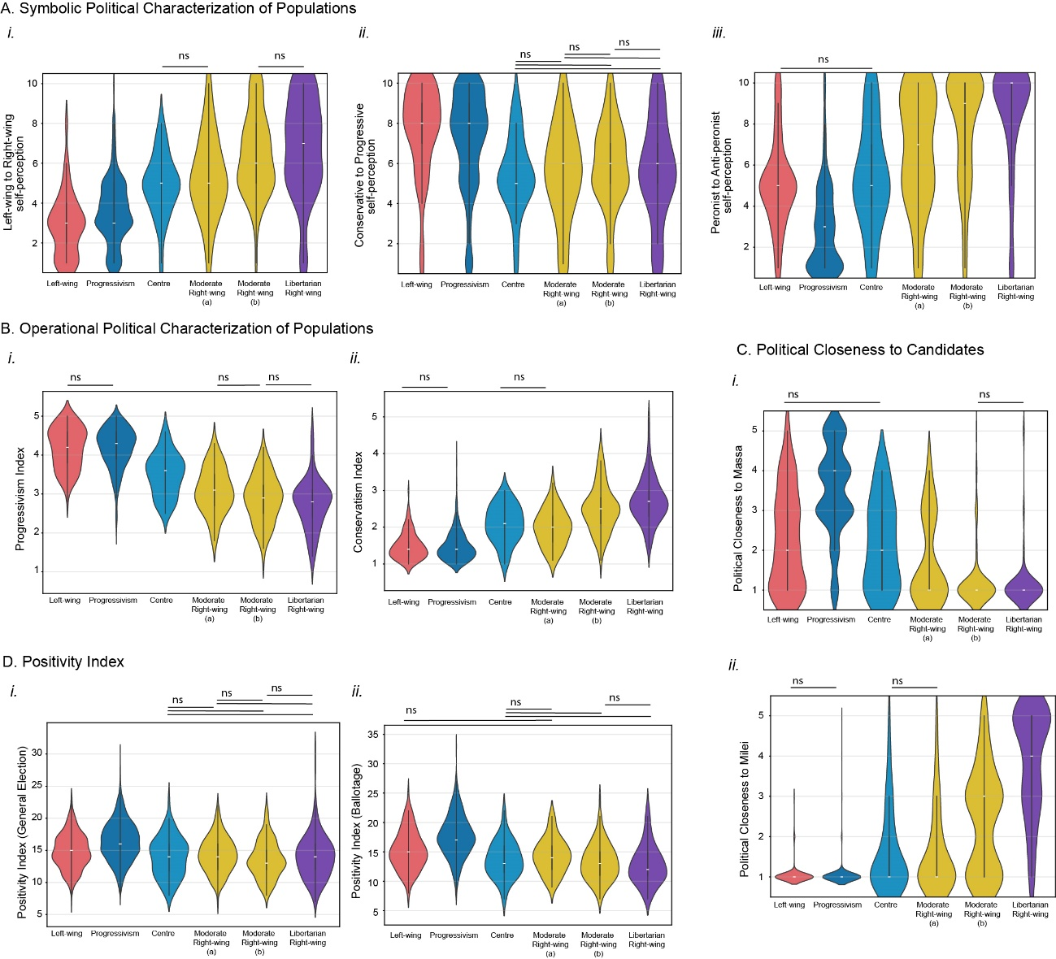
Supplementary Figure 1. Political Characterization of voting populations. A. Symbolic political characterization of Ballotage populations: i) Left-wing&Right-wing self-perception for each population (Kruskal-Wallis: p-value = 1,93e-68); ii). Conservative&Progressive self-perception for each population (Kruskal-Wallis: p-value = 7,87e-23); iii) Peronist/anti-peronist self-perception for each population (Kruskal-Wallis: p-value = 2,38e-88). B. Operational political characterization: i) Progressivism scale for each population (Kruskal-Wallis: p-value = 7,28e-100); ii) Conservatism scale for each population (Kruskal-Wallis: p-value = 3,30e-90). C. Political closeness to: i) Massa: Kruskal-Wallis: p-value = 1,14e-96; ii) Milei: Kruskal-Wallis: p-value = 2,20e-129. D. Positivity Index of: i. General Election (Kruskal-Wallis: p-value = 6,38e-59); ii. Ballotage (Kruskal-Wallis: p-value = 4,76e-54) populations. In all cases, post-hoc Dunn Test reveals by default significant differences in all comparations excepts when it was indicated as non-significant (ns).

Supplementary Figure 2
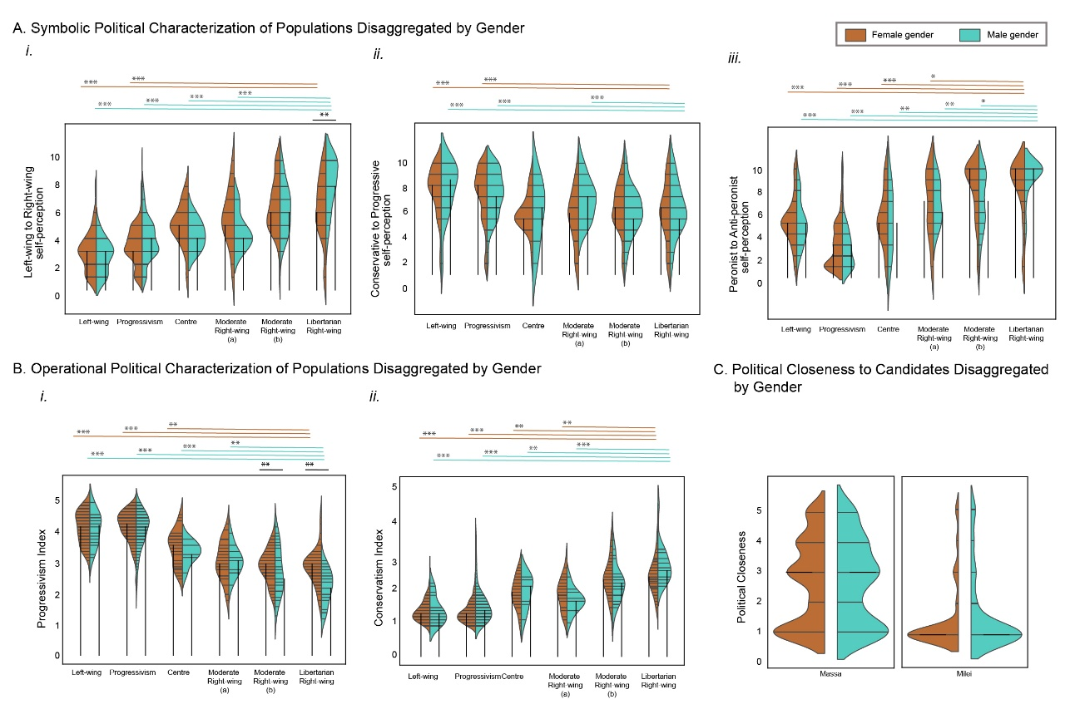
Supplementary Figure 2. Social Characterization of voting populations (Ballotage). A. Symbolic political characterization disaggregated by Gender and population: i) Left-wing&Right-wing self-perception; ii). Conservative&progressive self-perception; iii) Peronist&anti-peronist self-perception. B. Operational political characterization: i) Progressivism scale; ii) Conservatism scale. C. Closeness to candidates disaggregated by Gender. In all cases, Mann-Whitney U Test (two-sided) significant results are shown in orange for female comparations, cyan for male comparations and black for comparisons between females and males within the same population: * p-value < 0.05; ** p-value < 0.01; *** p-value < 0.001.

.

Supplementary Figure 3
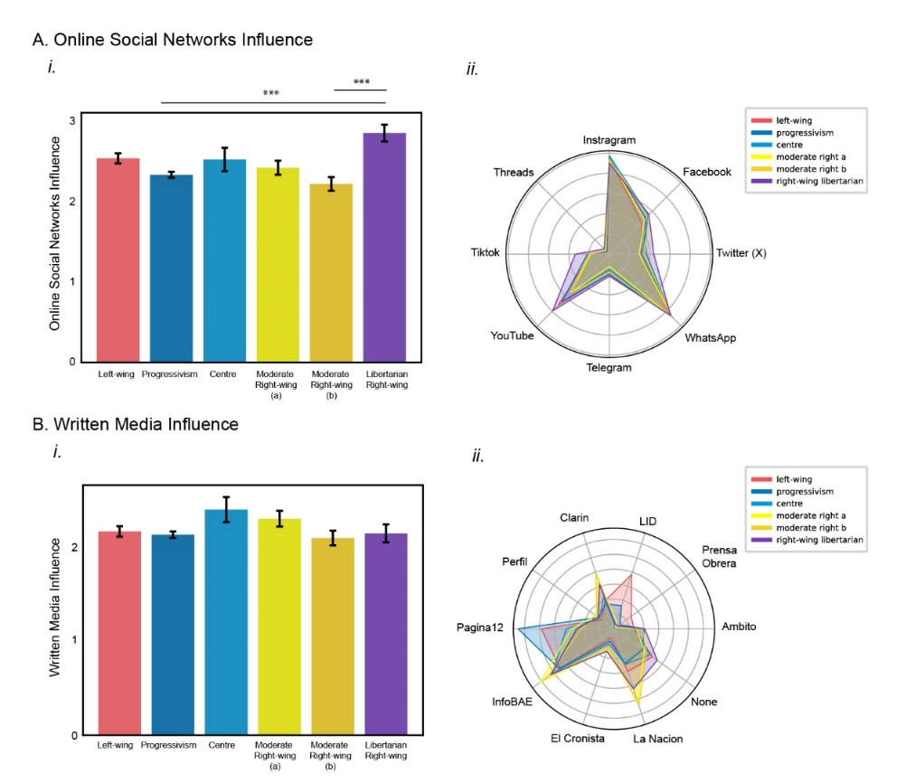
Supplementary Figure 3. Self-reported Influence of Information Media. A. Online Social Networks Influence: i) Mean (± SEM) of the self-reported influence: Kruskal-Wallis: p-value =4.75e-06. ii) Radar representation of each online social Network consumption for each population. B. Written Media Influence: i) Mean (± SEM) of the self-reported influence: Kruskal-Wallis: p-value =0.088. ii) Radar representation of each Written Media Outlet consumption for each population. Post-hoc Dunn Test reveals significant differences (***p-value < 0.001).

Supplementary Figure 4
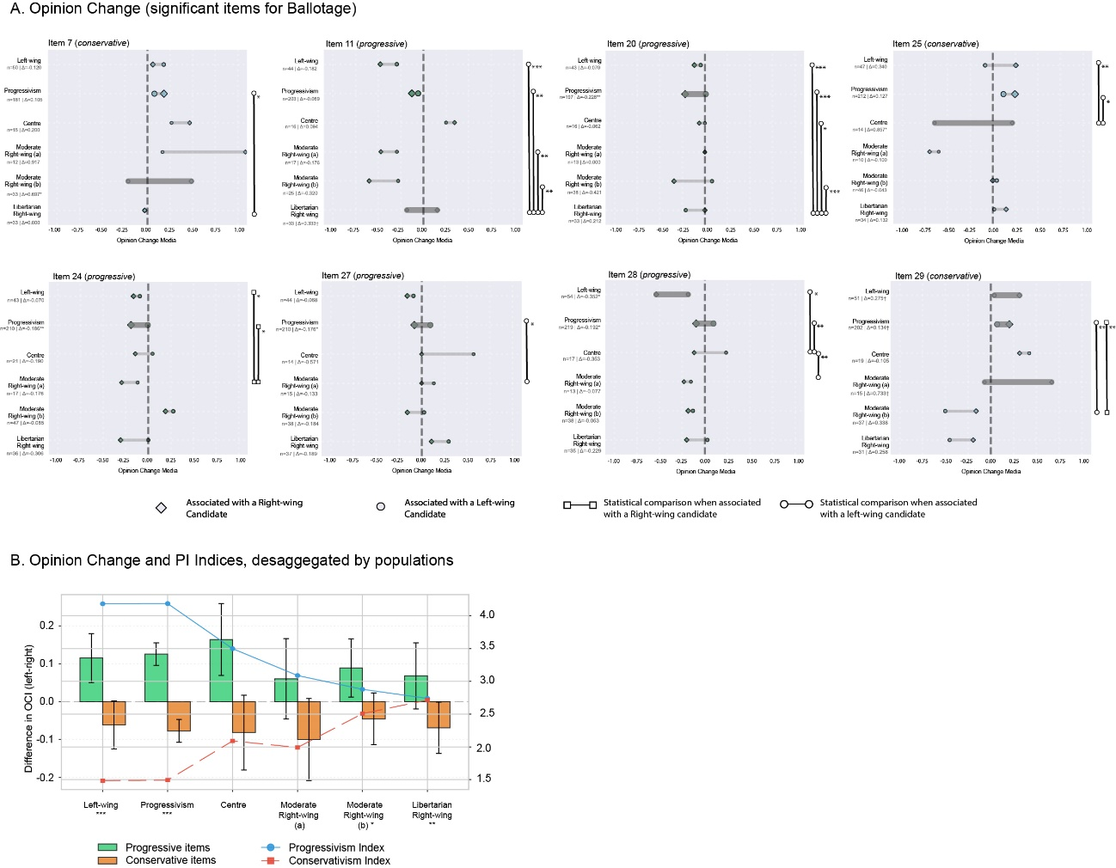

Supplementary Figure 4. Opinion Change of items (Ballotage). A. Opinion Change of significant items desegregated by populations: the diamonds represent Opinion Change of items associated with right-wing candidates, while the circles represent left-wing candidates’ association. Significant differences between left-wing & right-wing association were assessed using the Wilcoxon test; and between populations, Dunn Test with Bonferroni correction: * p-value < 0.05; ** p-value < 0.01; *** p-value < 0.001. B. Differences between the rates of opinion change associated with left-wing and right-wing candidates (shown separately for progressive and conservative items) and the indices of progressivism and conservatism, disaggregated by voter populations. Significant differences between left-wing & right-wing association were assessed using the Wilcoxon test: * p-value < 0.05; ** p-value < 0.01; *** p-value < 0.001.

